Submitted To :

Rabia Akter   
Junior Instructor  
Computer Deptartment  
Sylhet Polytechnic Institute

Documentation of Project SPI

Static Institute Webpage Design

Created by :

* Md. Muhibbur Rahman [577952]
* Md. Alfi Mia [577961]
* Ajijoul Hakim [577948]
* Sadikul [577982]
* Jhulon Kumar [577962]
* Mohiuddin Naeem [577971]

Project SPI is our first ever project that displays a concept of institute webpage. This Project contains every necessary objects, contents and other detail about a institute website. We, our group has completed the project in shorter times for make it more challenging. We think that making a project challenging is best for our team members. We proud for our guideline and instructor(junior) “Mst. Rabia Akter” to help and train us to make the project far better.   
Note : This webpage may contain real details about teacher, lab, and so on. But we cannot guarantee you that they are fully similar with Sylhet Polytechnic Institute.

Thank You

- Muhib’s Group

* Overview :

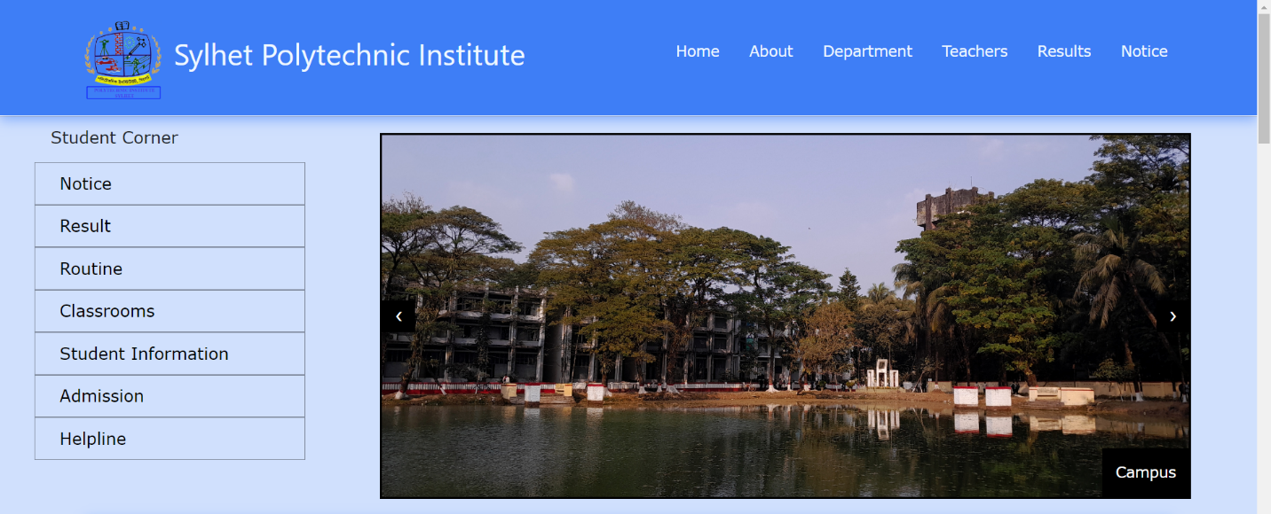

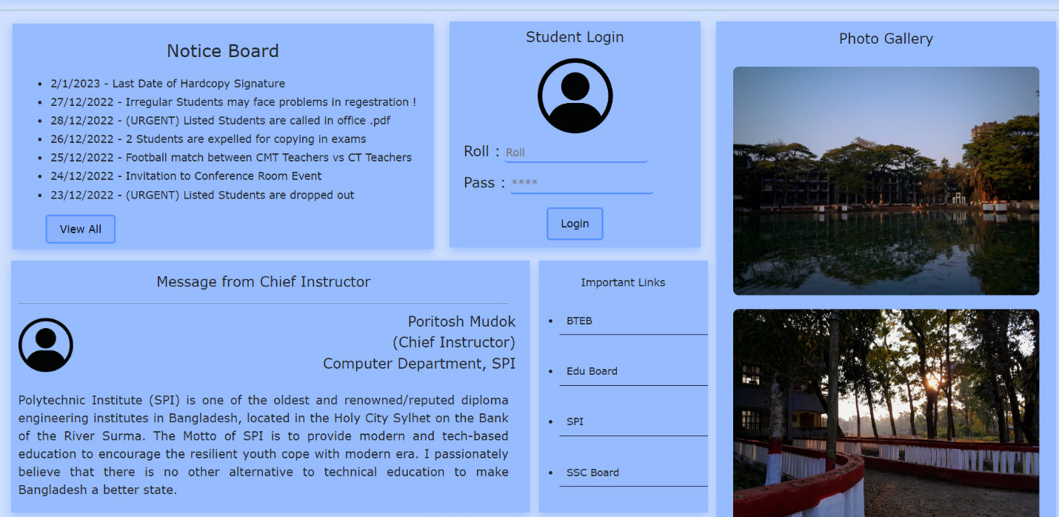

Main Page (index.html)

**Table of Contents**

1. Main Page (index.html)

* Navbar
* Slide
* Lab Details
* Projects
* Notice Board
* Login Section
* Photo Gallery
* Links
* Speech
* Location
* Contact
* Footer

1. Routine
2. Admission Form
3. Result
4. Lab Details
5. Teacher’s List
6. Student List
7. Notice List

Index.html (code) :

Student Corner (code) :

<div class="col-lg-3"><!--stdcorner col-->

<p class="text-stdcorner">Student Corner</p>

<ul class="student-corner-ul">

<li><a href="files/notice/notice.html" target="_blank">Notice</a></li>

<li><a href="files/result/result.html" target="_blank">Result</a></li>

<li><a href="files/routine/index.html" target="_blank">Routine</a></li>

<li><a href="#">Classrooms</a></li>

<li><a href="files/std-list/index.html" target="_blank">Student Information</a></li>

<li><a href="files/admission-form/admission-form.html" target="_blank">Admission</a></li>

<li><a href="#">Helpline</a></li>

</ul>

</div>

Lab Details (code) :

<div class="section-row row">

<div class="section-content col-lg-6">

<img src="res/lab/sw-lab.jpeg" alt="lab" class="section-content-img">

</div>

<div class="section-content col-lg-6">

<p class="section-content-title">Software Lab</p>

<p class="section-content-desc">We have a rich Software LAB in our department building contains 40+ active computers. All PC's in SW LAB is high performanced pc for education, research, machine learning, software and development based. Many popular softwares are made by our students from SW LAB. We have been working on inertia sensor based activity recognition, eye tracking based mouse pointer, human intention and attention detection, hand and body gesture recognition, accelerometer based chair gesture recognition etc. We sometimes focus on applications to facilitate special group, for example speech based text correction tool.</p>

<a href="files/lab/sw-lab.html" target="_blank" class="lab-details-btn">Details</a>

</div>

</div>

Notice (code) :

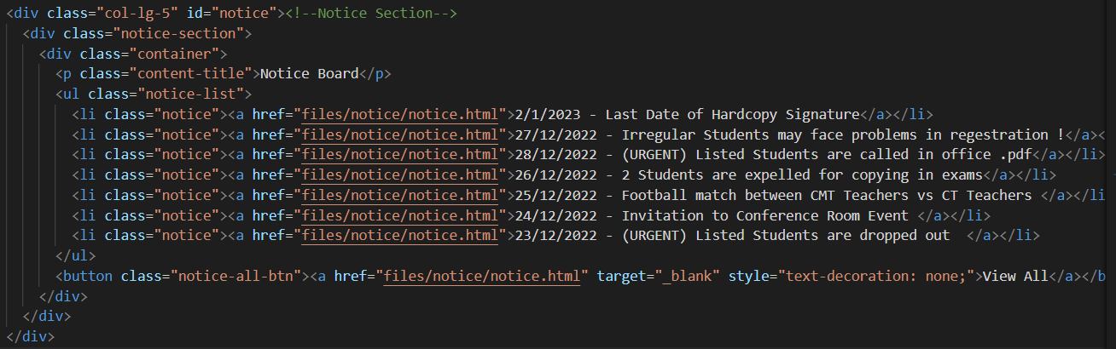

Map, Contact (code) : 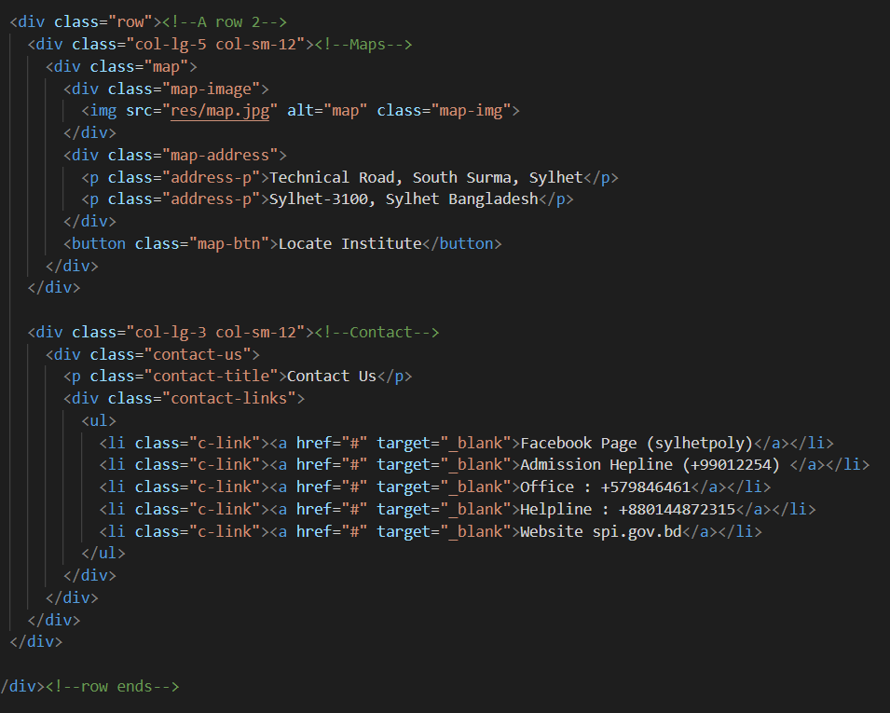

Gallery (code) :

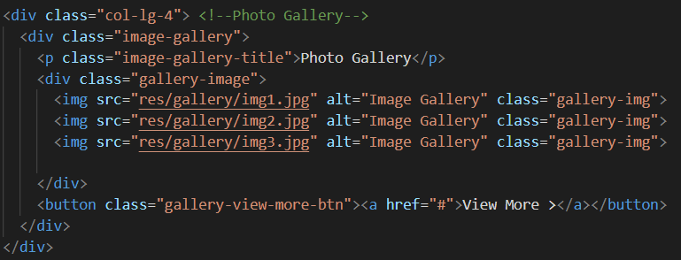

Teacher-List (code) :

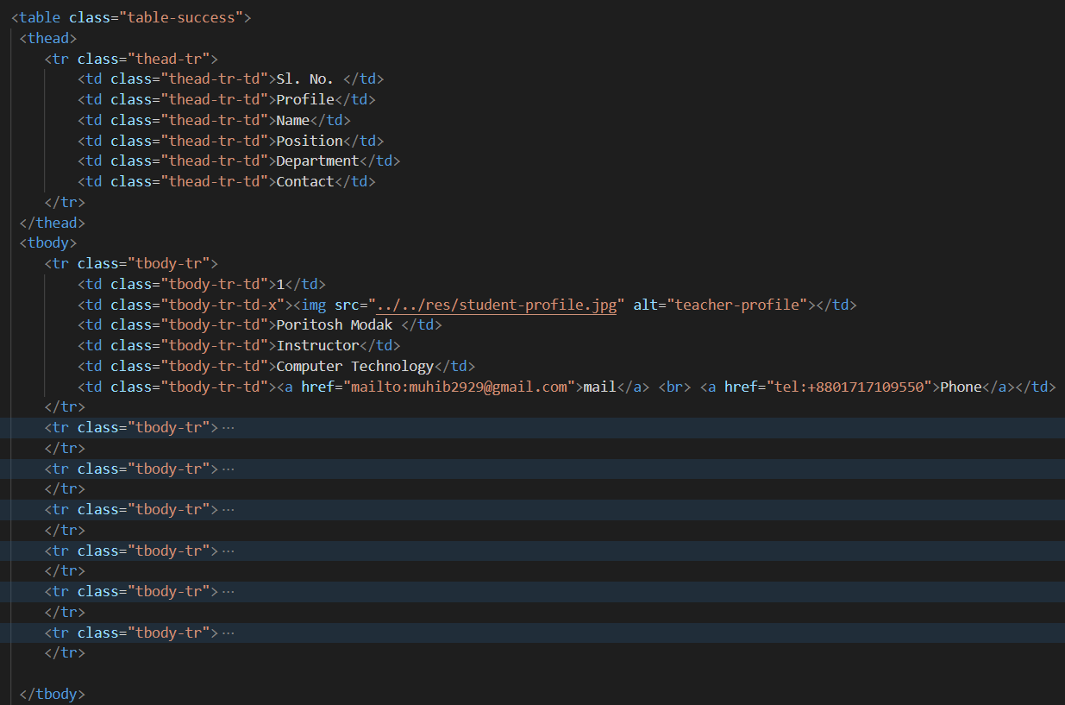

**Contributors :**

Md. Muhibbur Rahman [577952] :

* index Page
* CSS, JS Overview
* Presentation
* Overall Management

Md. Alfi Mia [577962]:

* Routine (files/routine/index.html)
* Notice List (files/notice/notice.html)
* Layout Designer

Sadikul [577982] :

* Lab Details (files/lab)
* Documentation
* Powerpoint Slide

Ajijoul Hakim [577982] :

* Result (files/result.html)
* Admission Form (admission-form/form.html)

Mohiuddin Naeem [577971] :

* Teacher List (files/teachers-list/teachers.html)
* Student List (files/std-list/index.html)

Jhulon Kumar Roy [577961] :

* Resource Collector (image, Description)
* Responsive Design